

New Zealand Diploma in System Administration Level 6

IAC601: Infrastructure as Code

Assessment/Aromatawai - Assessment 1  
Version 1 Credits 12

Practical Assessment



|  |  |  |  |
| --- | --- | --- | --- |
|  | Submission | FER1 | FER2 |
| Result | Click or tap here to enter text. | Click or tap here to enter text. | Click or tap here to enter text. |
| Date | Click or tap to enter a date. | Click or tap to enter a date. | Click or tap to enter a date. |
| Assessor’s Signature |  |  |  |

|  |  |
| --- | --- |
| Student Name | Hui(Spark) ZHENG |
| Student ID | AEU3000774 |
| Student Signature | Spark |
| Assessor | Click or tap here to enter text. |

Assessor’s Feedback

|  |
| --- |
| Submission |
| Click or tap here to enter text. |

|  |
| --- |
| FER1 |
| Click or tap here to enter text. |

|  |
| --- |
| FER2 |
| Click or tap here to enter text. |

Table of Contents

Part 1 4

Task 4: Pre- and Post-Deployment Implementation for a new client machine 4

# Part 1

## Task 4: Pre- and Post-Deployment Implementation for a new client machine

**1. Execute the deployment PowerShell script step by step:**

* **Add MDT snap-in to support PowerShell cmdlets and create a new share folder for the deployment**

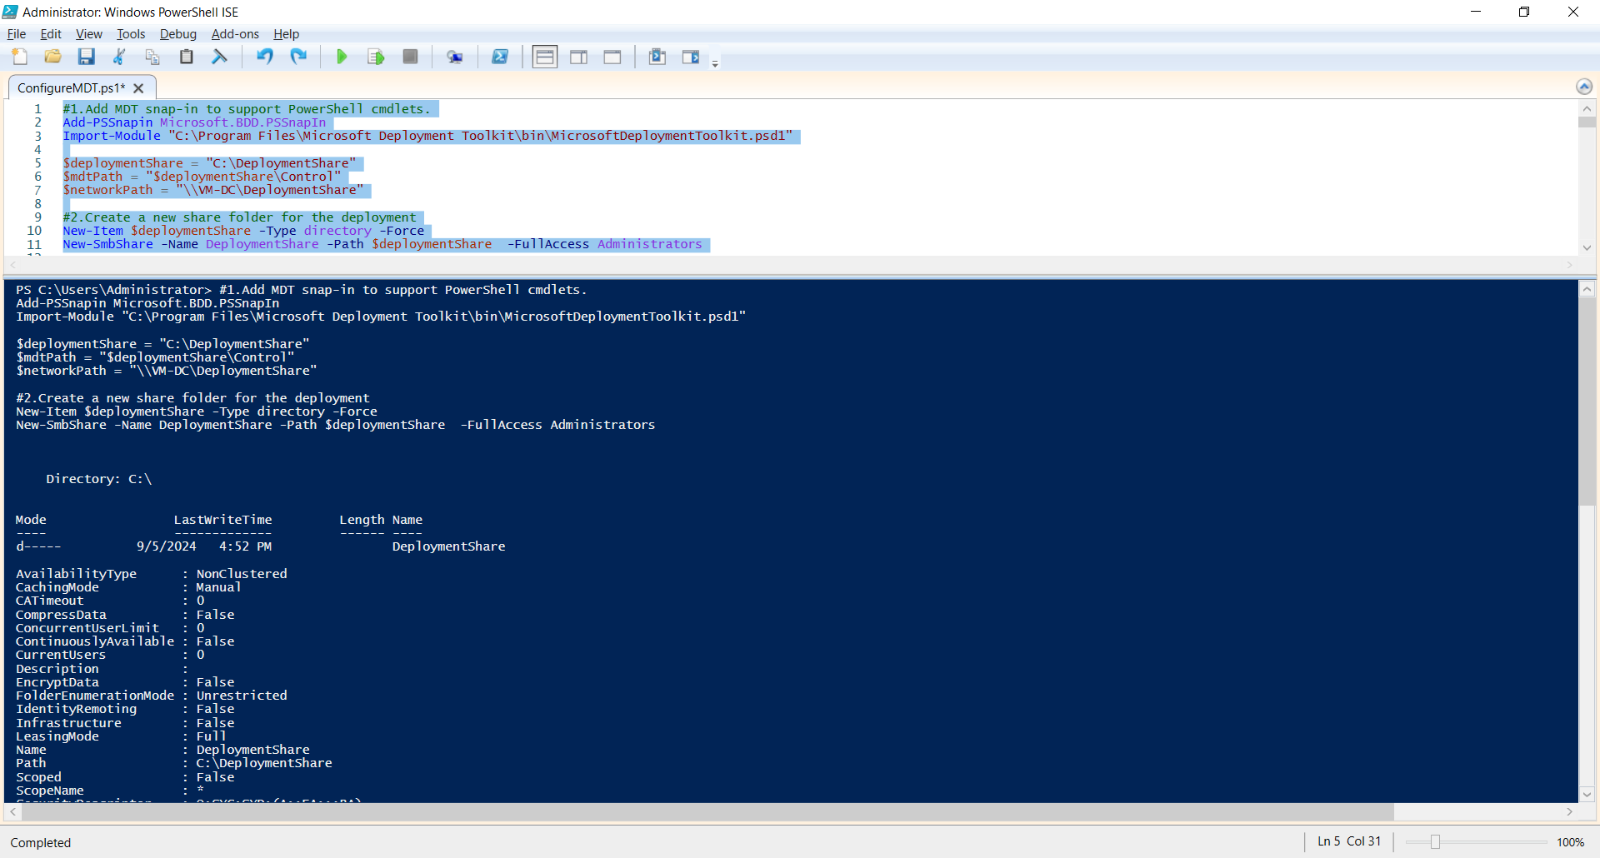

* **Initialize the deployment folder as a persistent drive named "DS00**

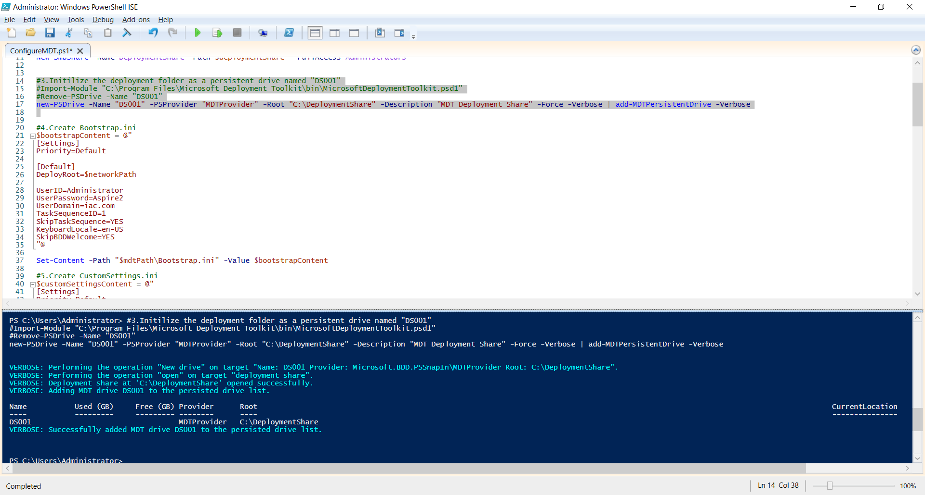

* **Create Bootstrap.ini**

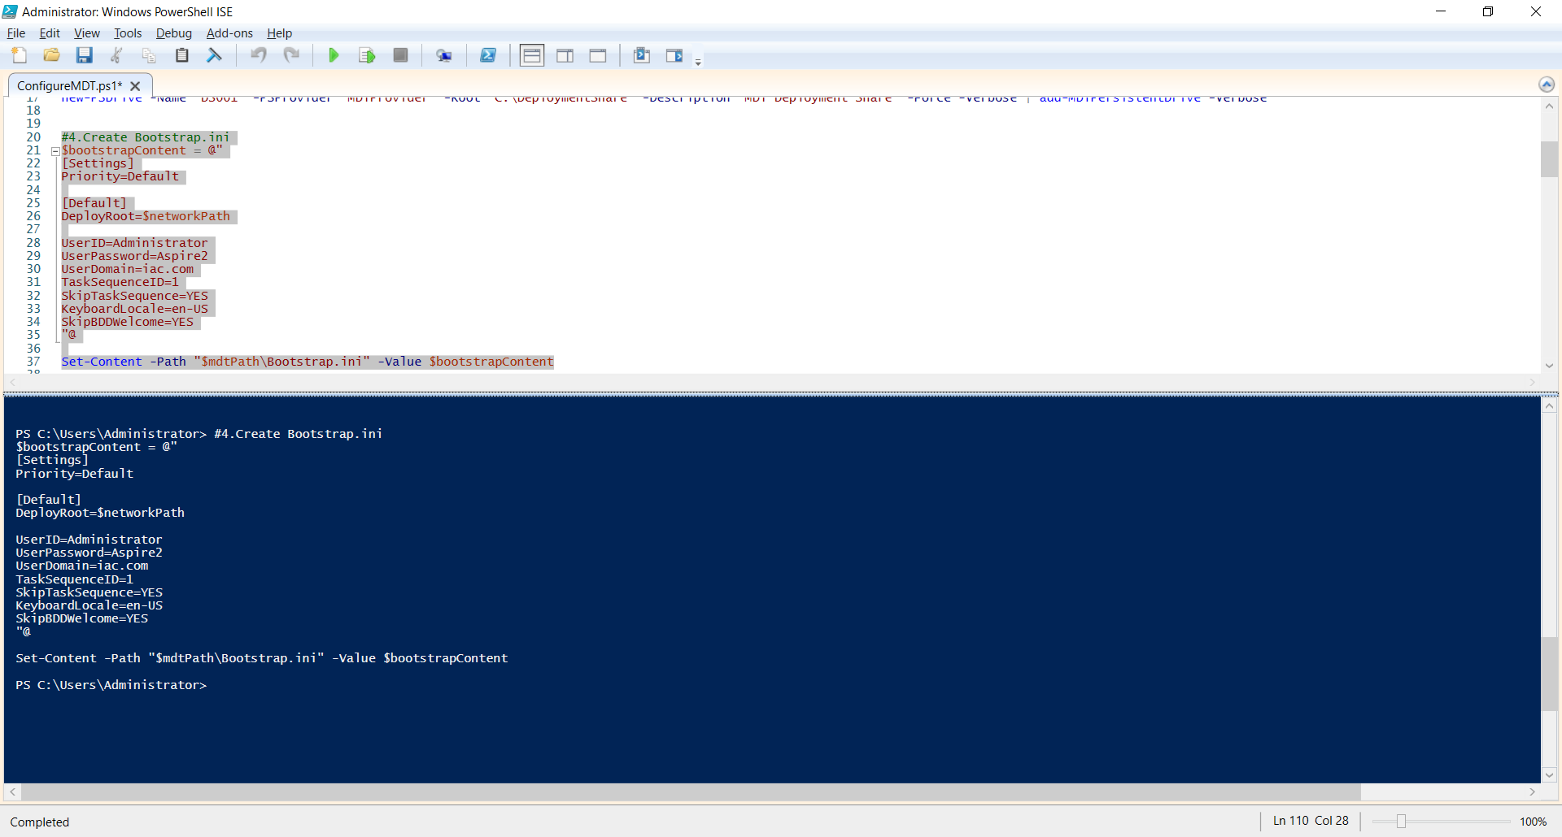

* **Check Bootstrap.ini created on the MDT management console:**

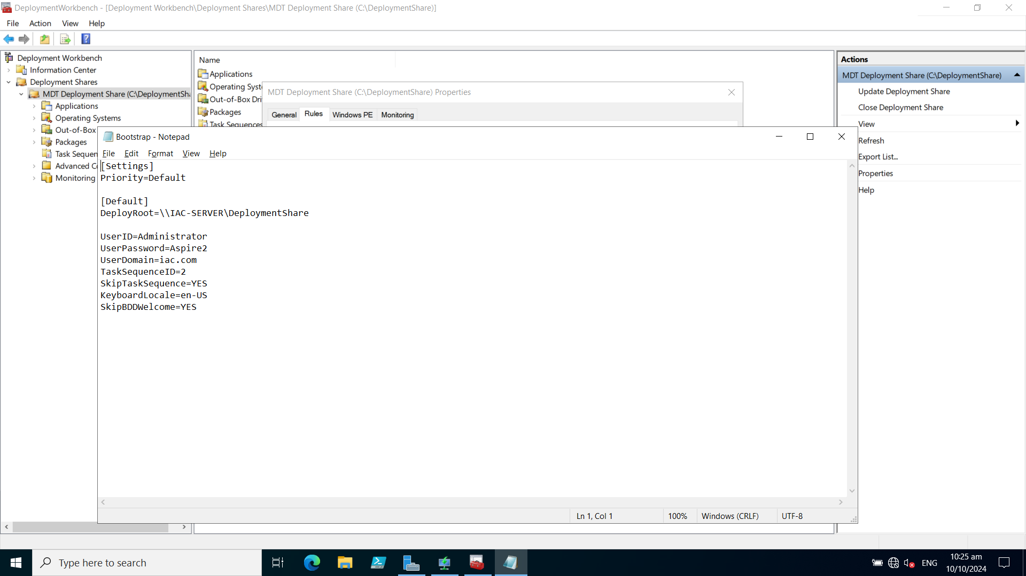

* **Create CustomSettings.ini**

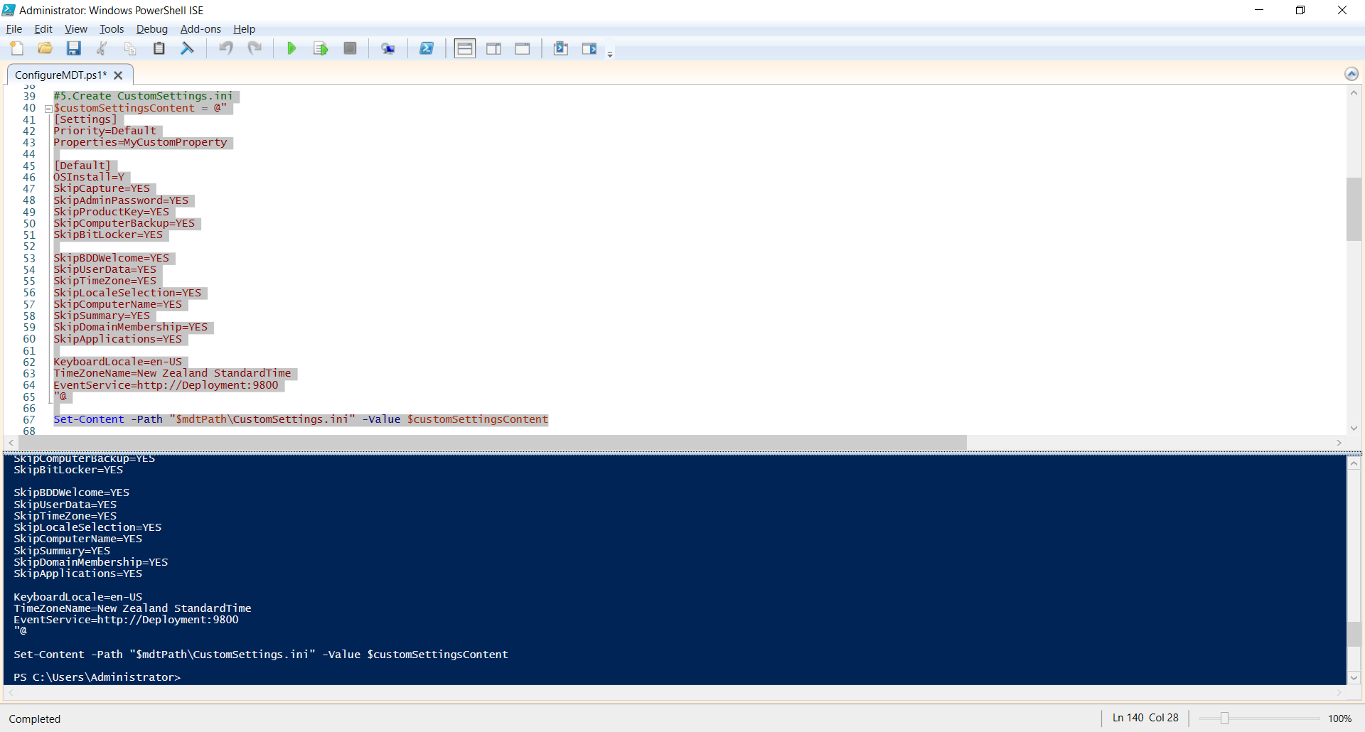

* **Check CustomSettings.ini on the MDT management console:**

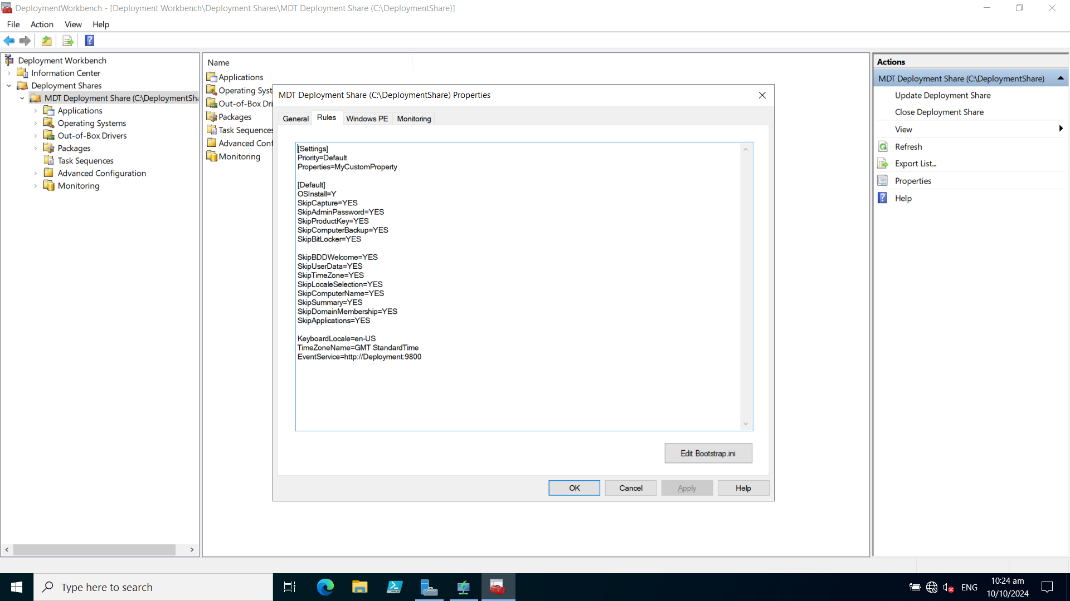

* **Import Applications (Chrome, VLC and Acrobat Reader) into MDT**

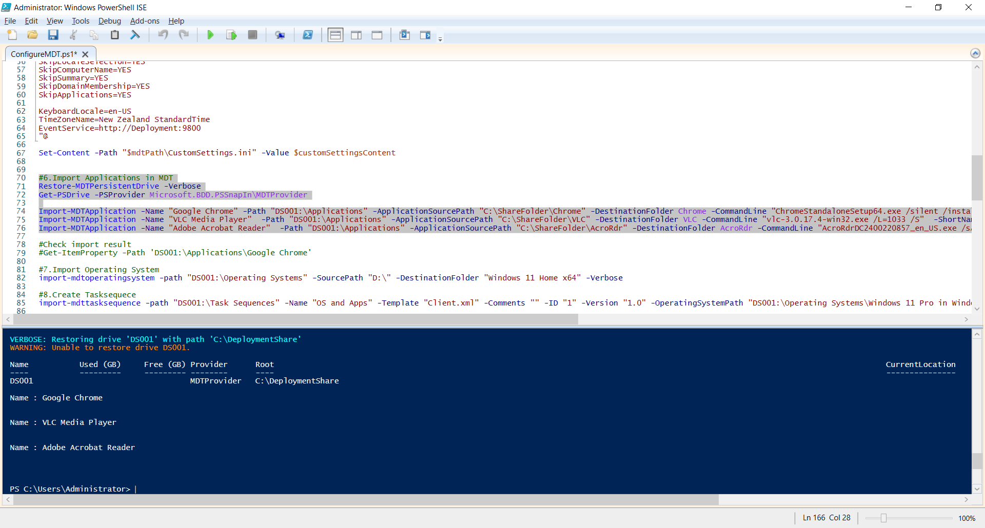

* **Check imported applications on the MDT management console:**

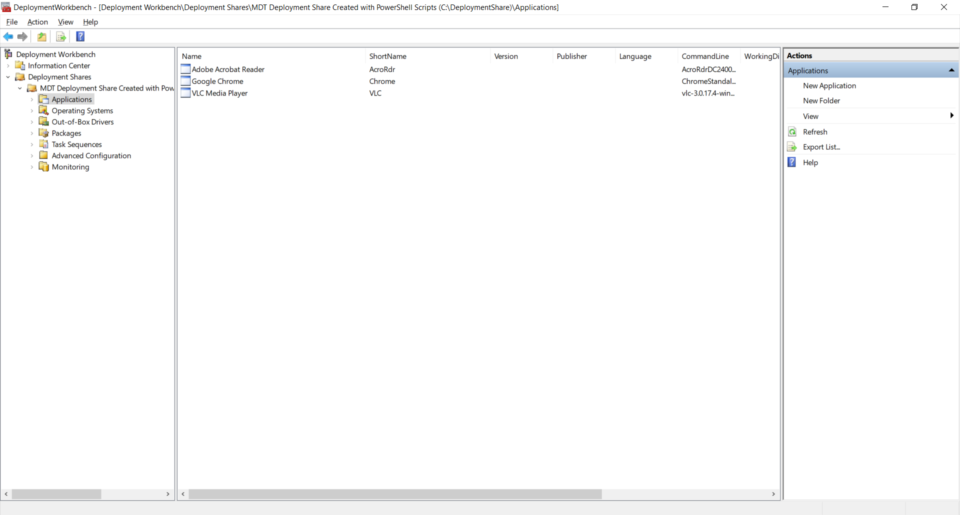

* **Import Operating System**

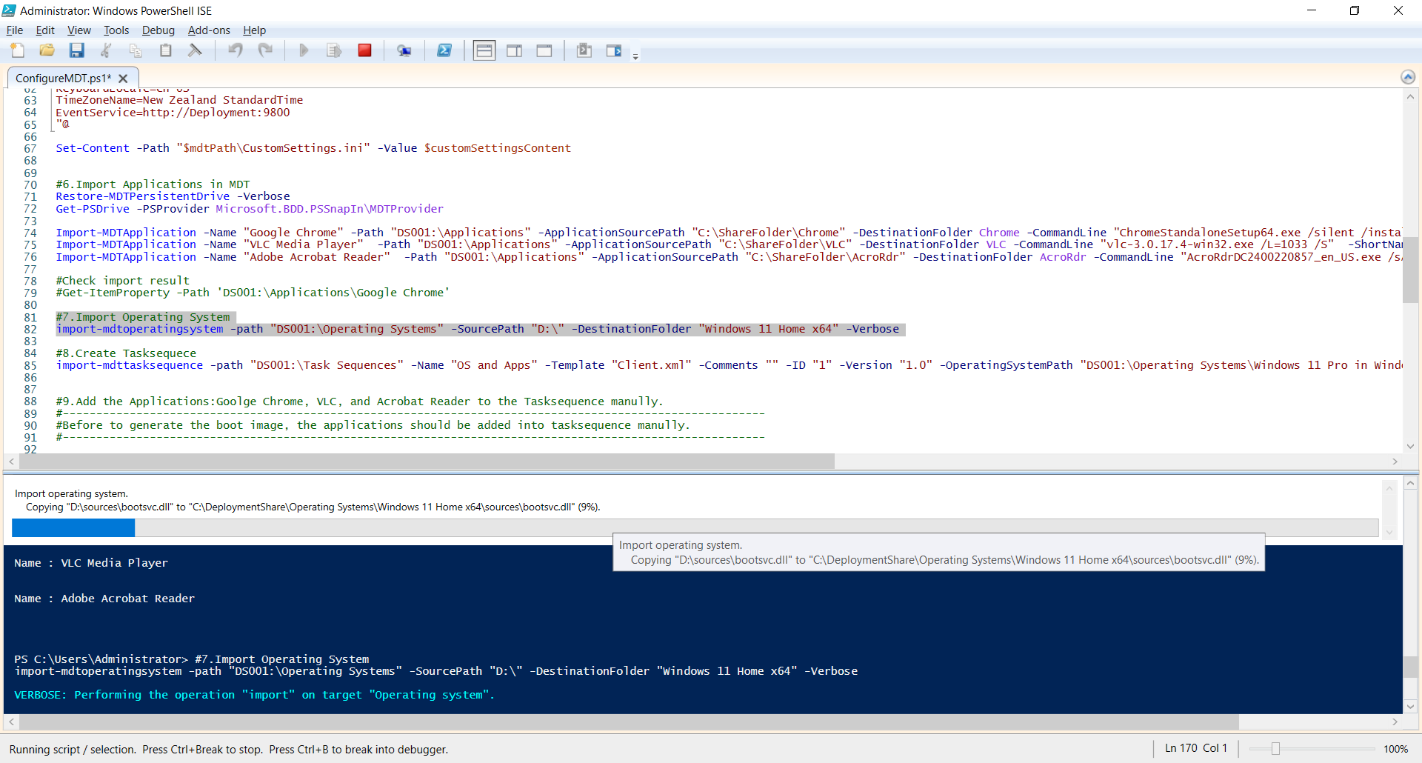

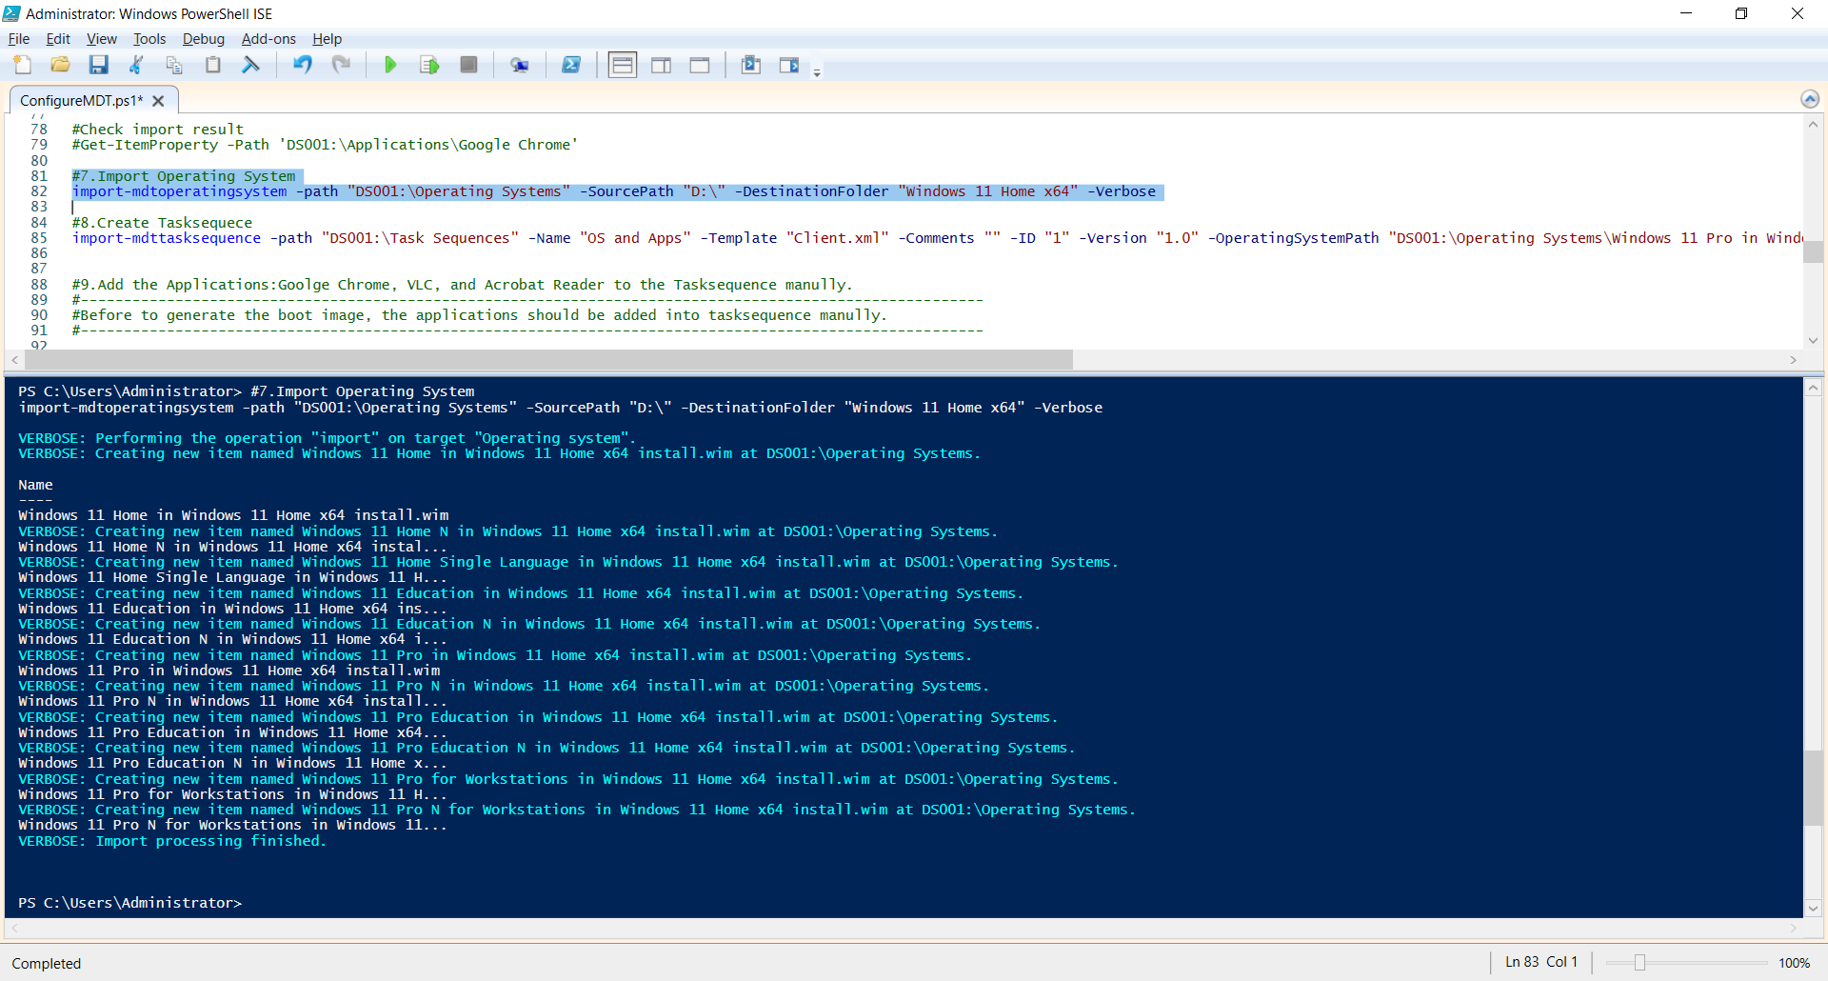

* **Check imported Windows 11 on the MDT management Console.**

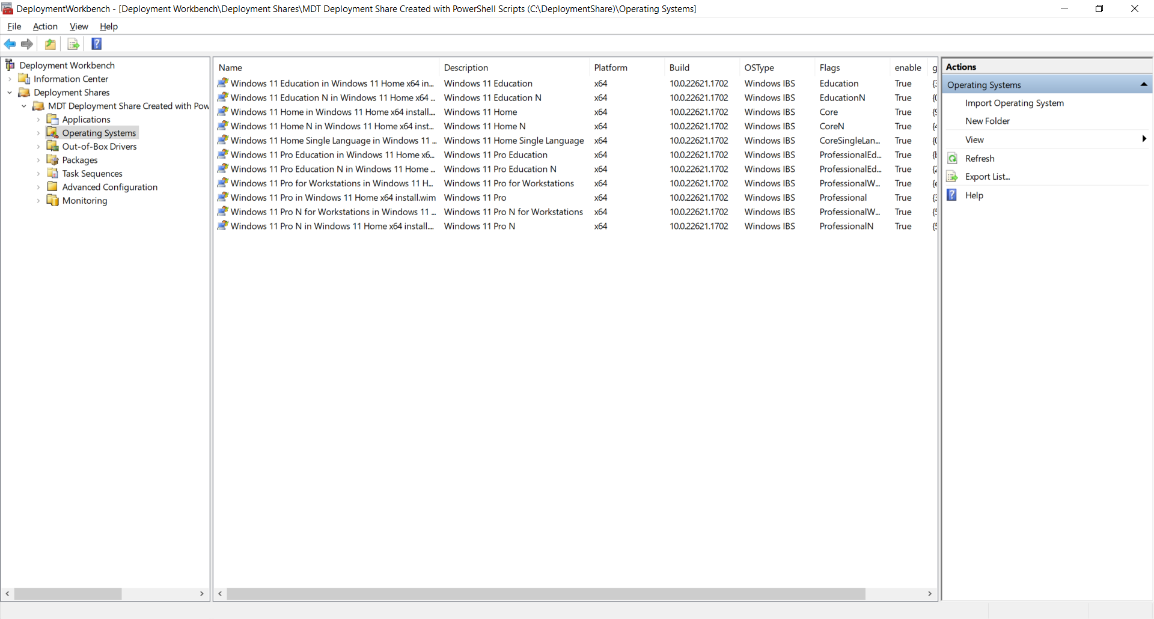

* **Create Tasksequece**

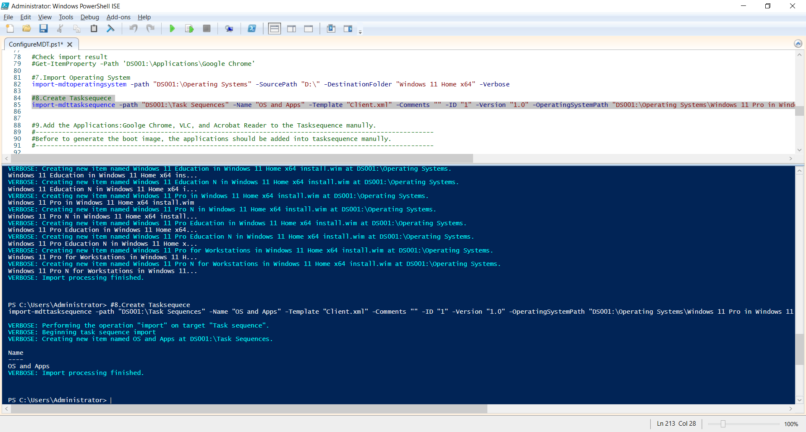

* **Add the Applications: Google Chrome, VLC, and Acrobat Reader to the Tasksequence manually.**

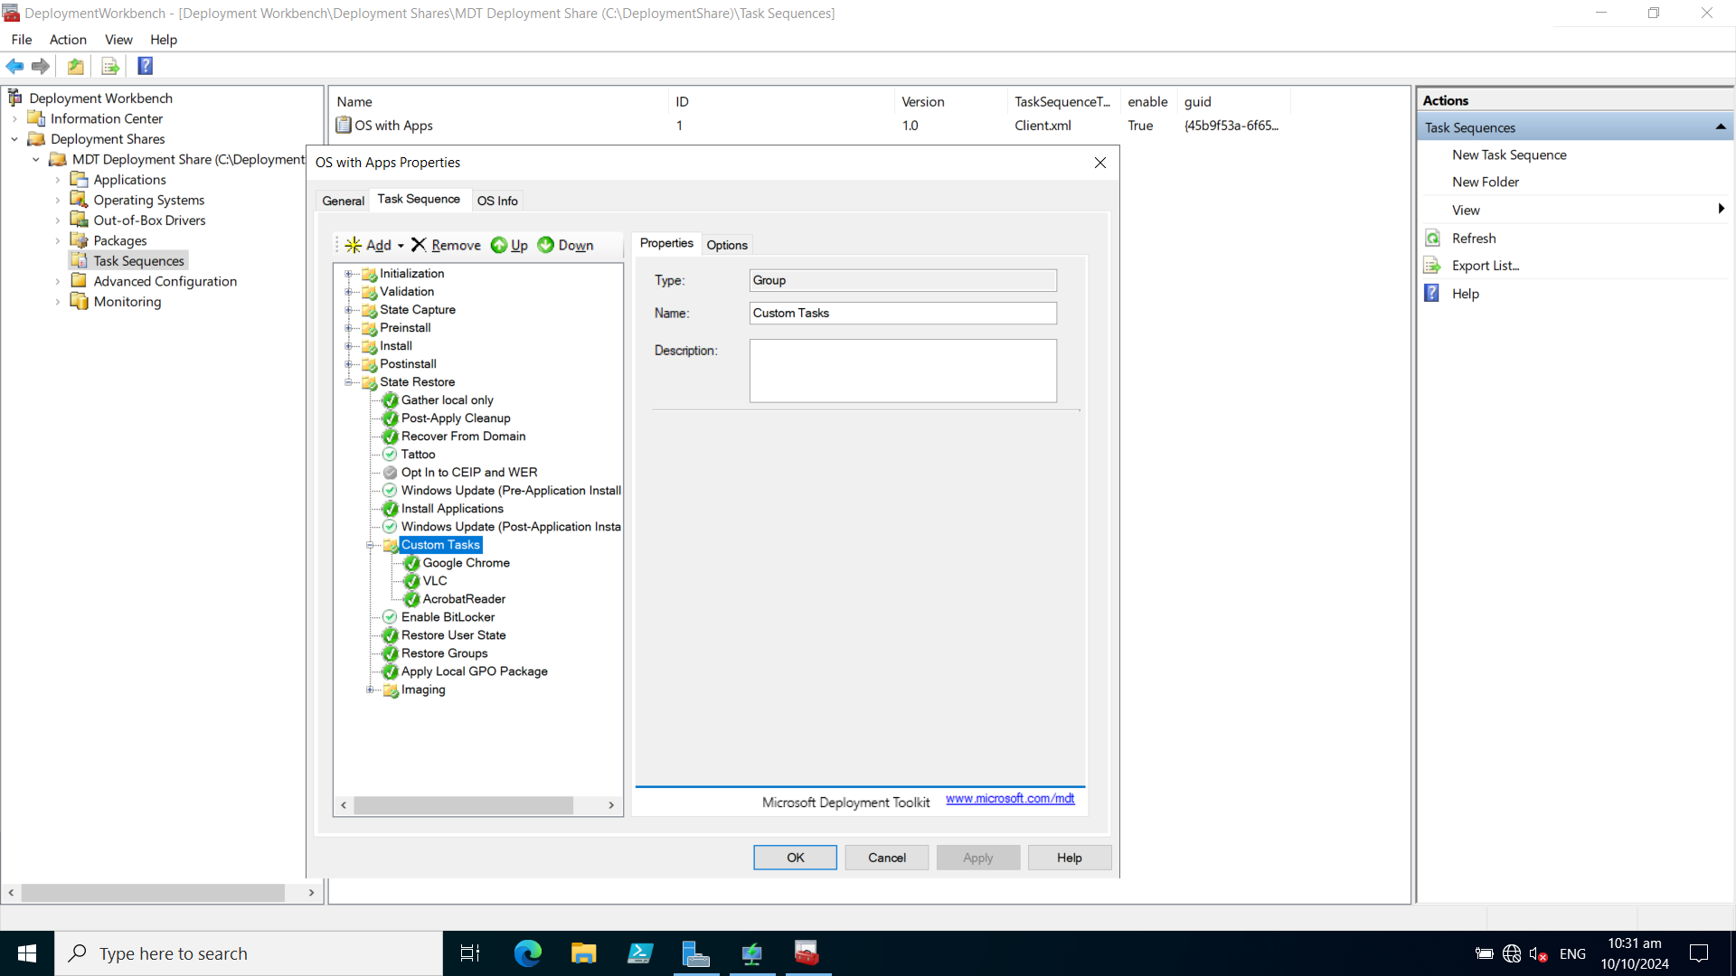

* **Generate the boot image**

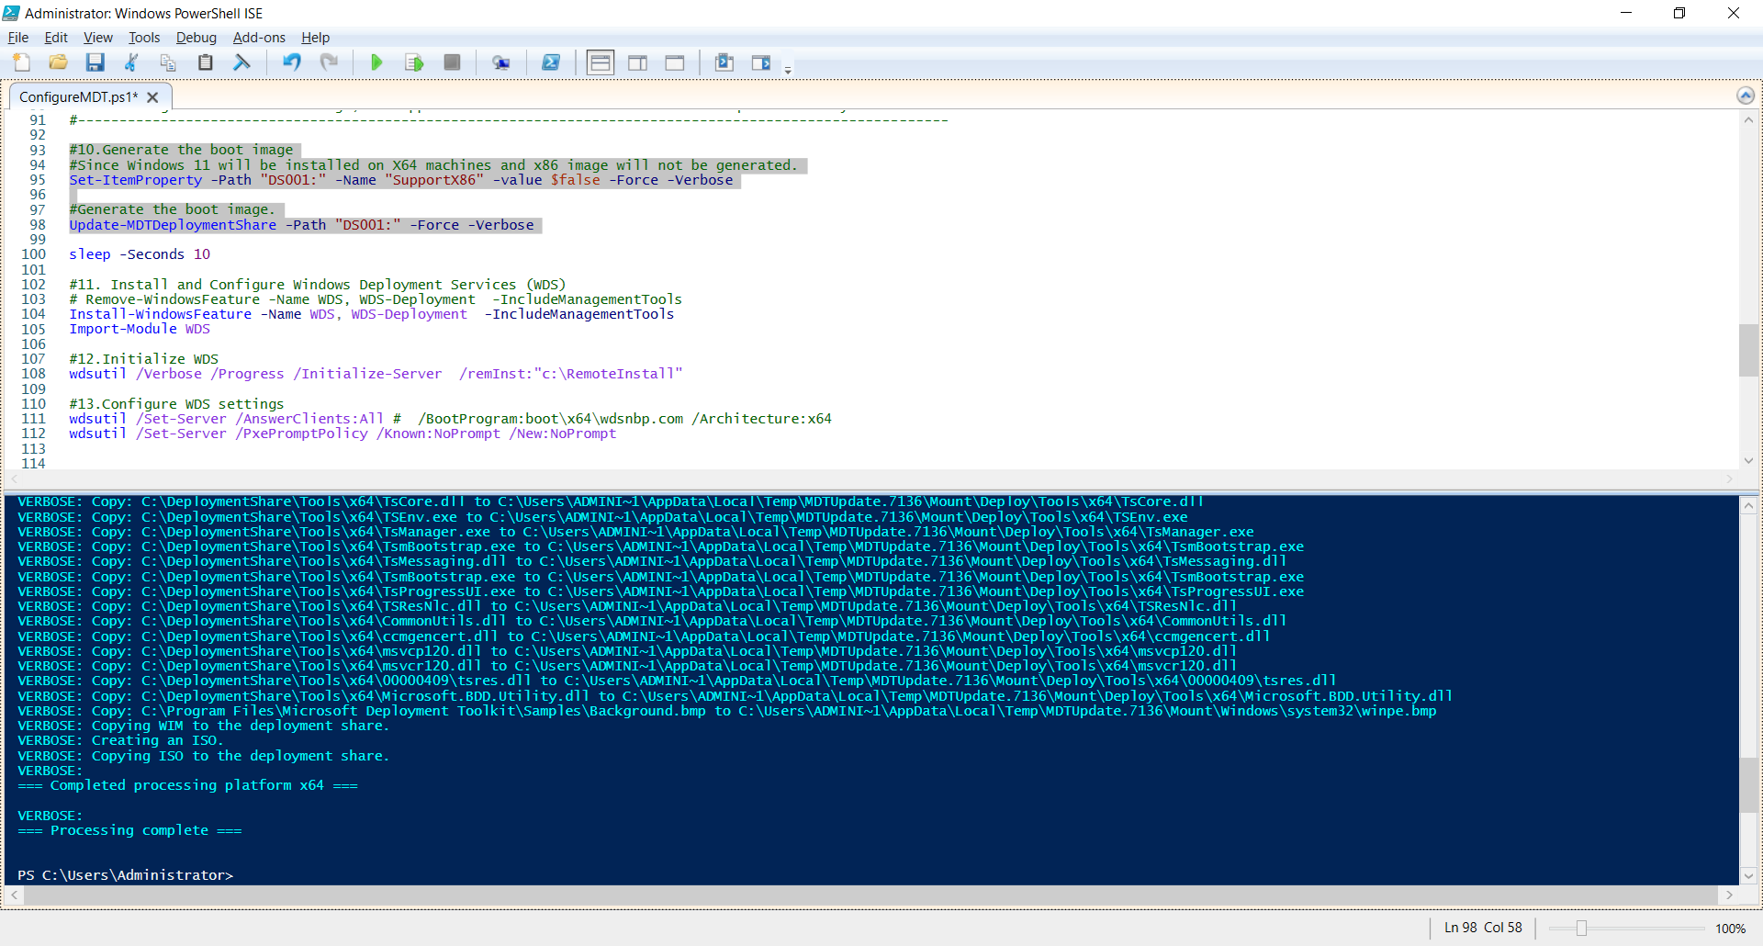

* **Install and Configure Windows Deployment Services (WDS)**

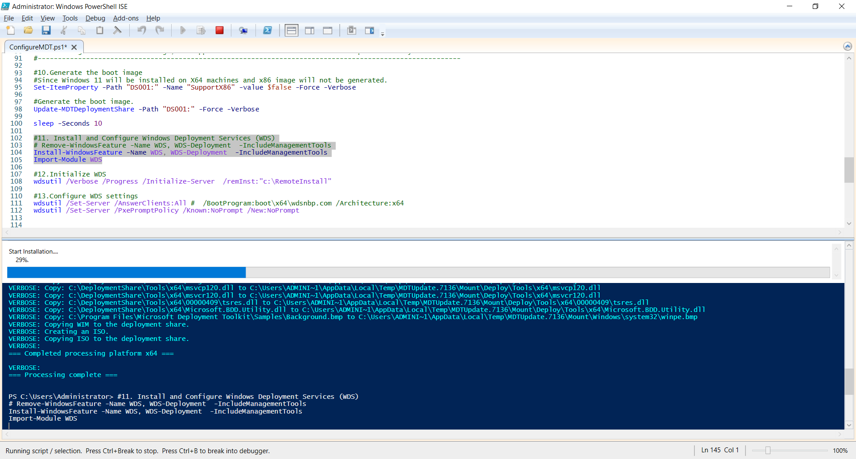

* **Initialize WDS**

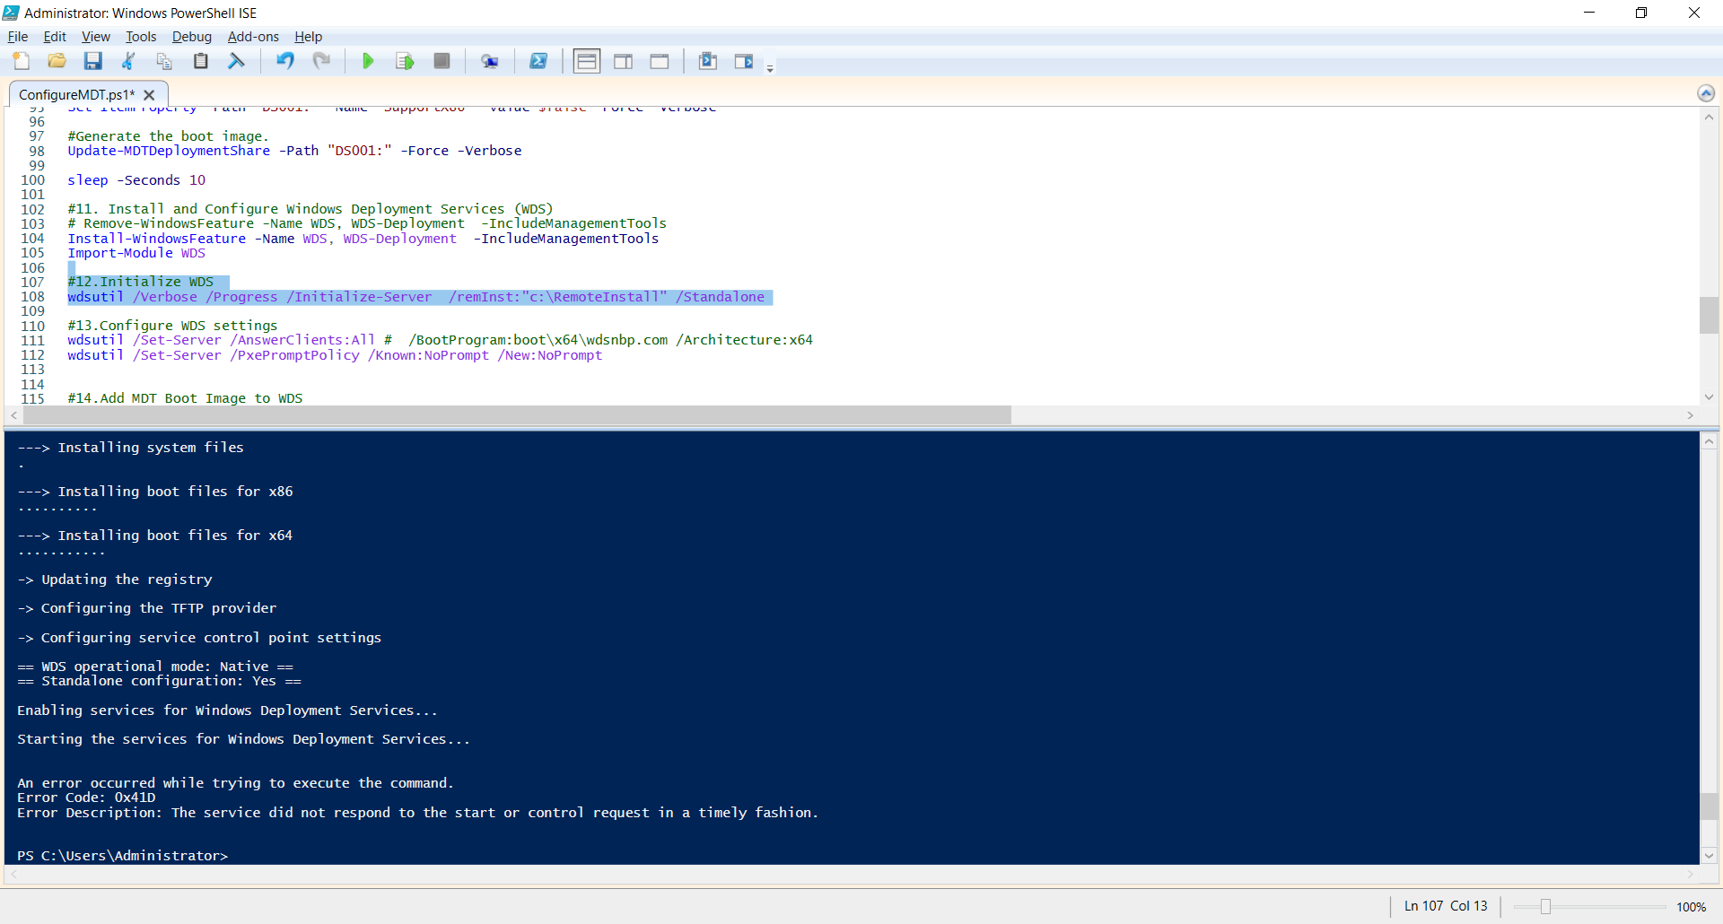

* **Configure WDS settings**

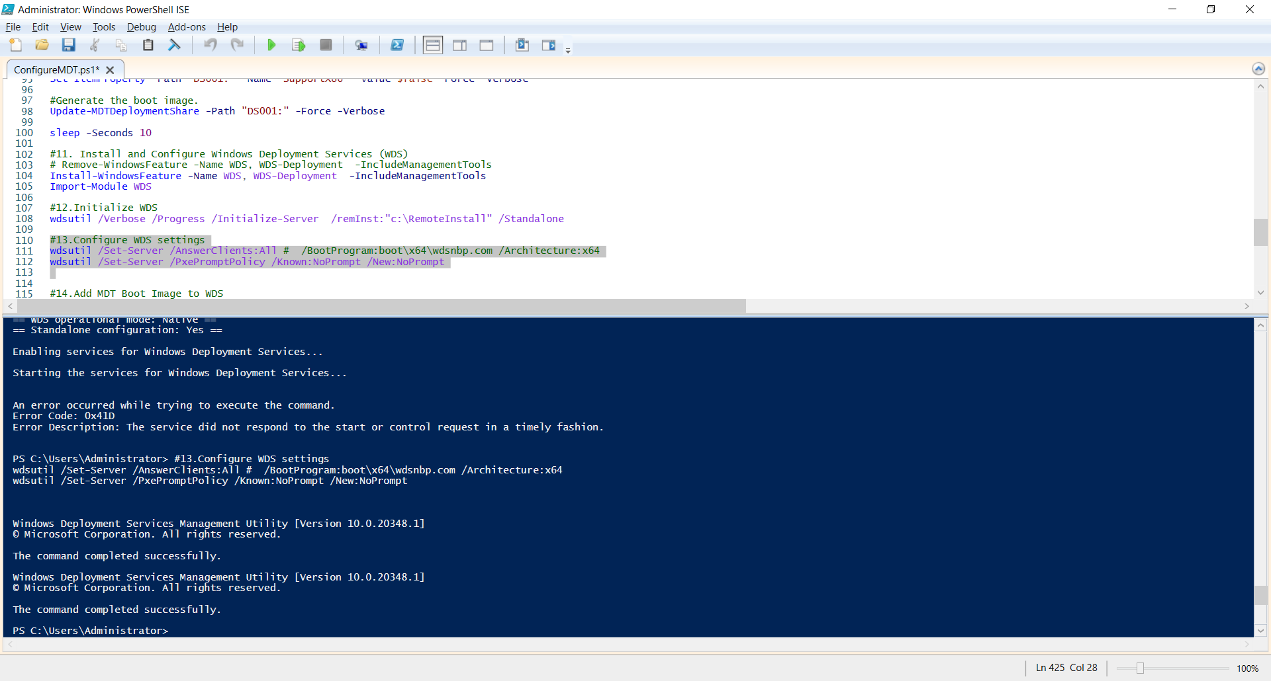

* **Start Windows Deployment Service**

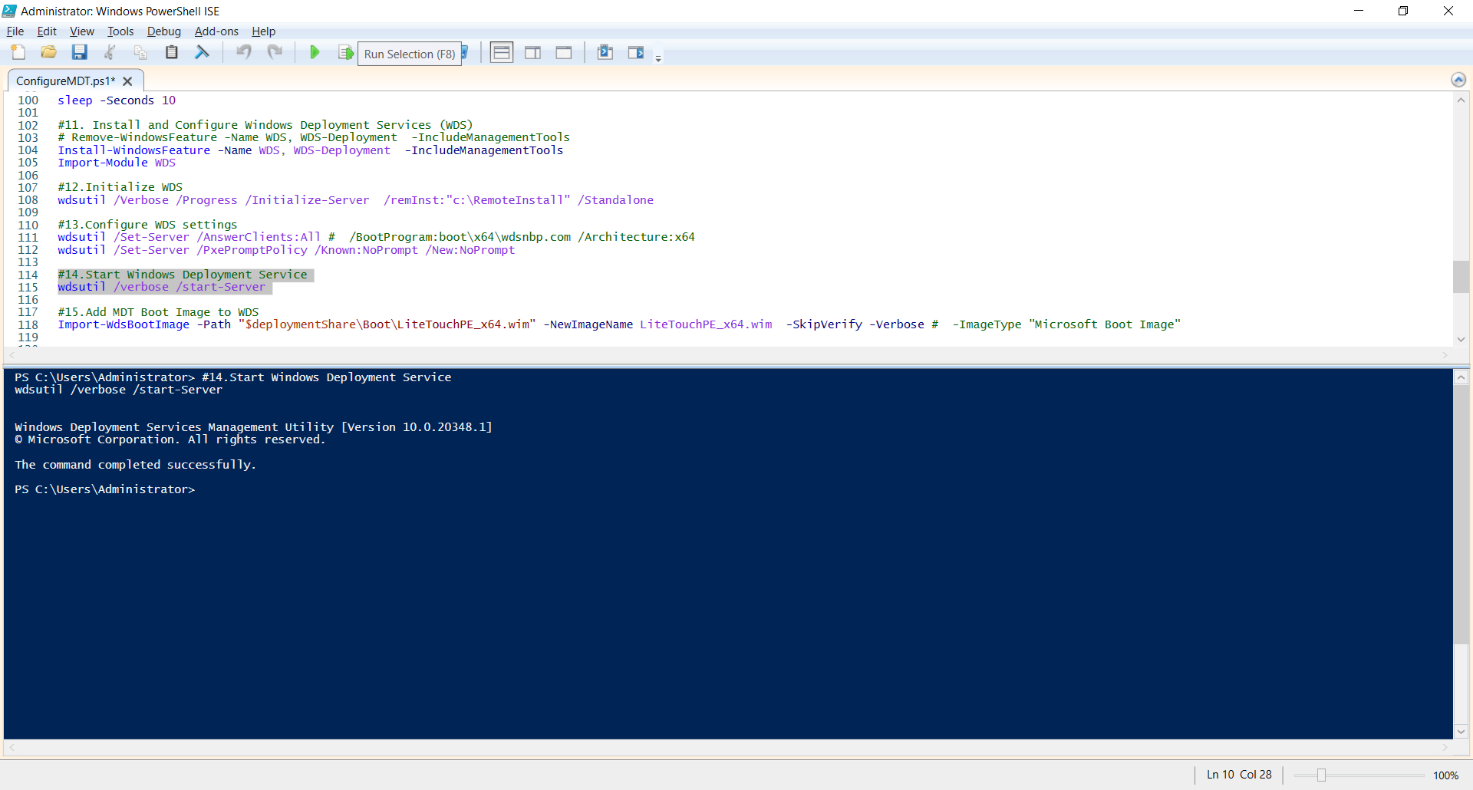

* **Add MDT Boot Image to WDS**

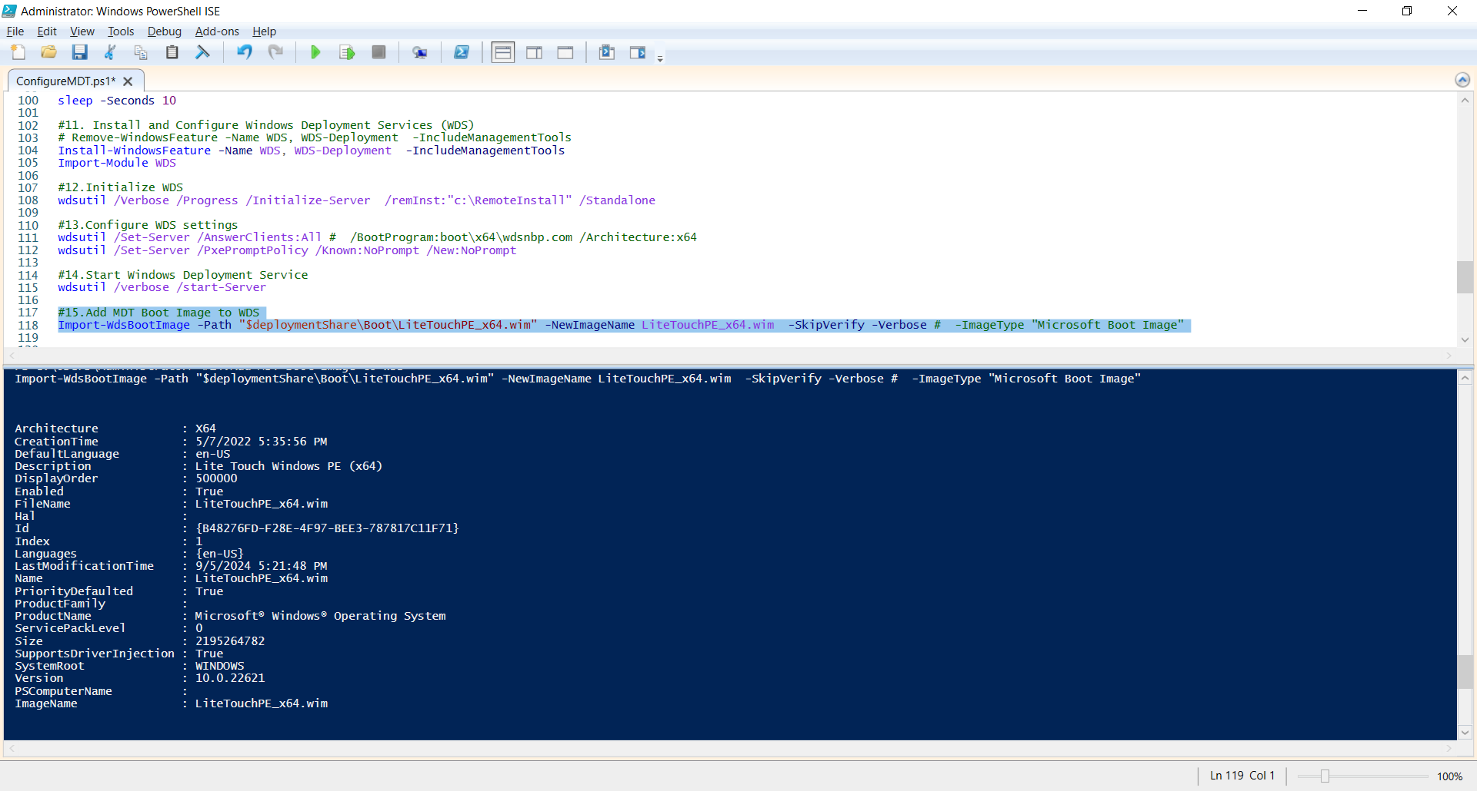

* **Check boot image added on the Windows Deployment Service console:**

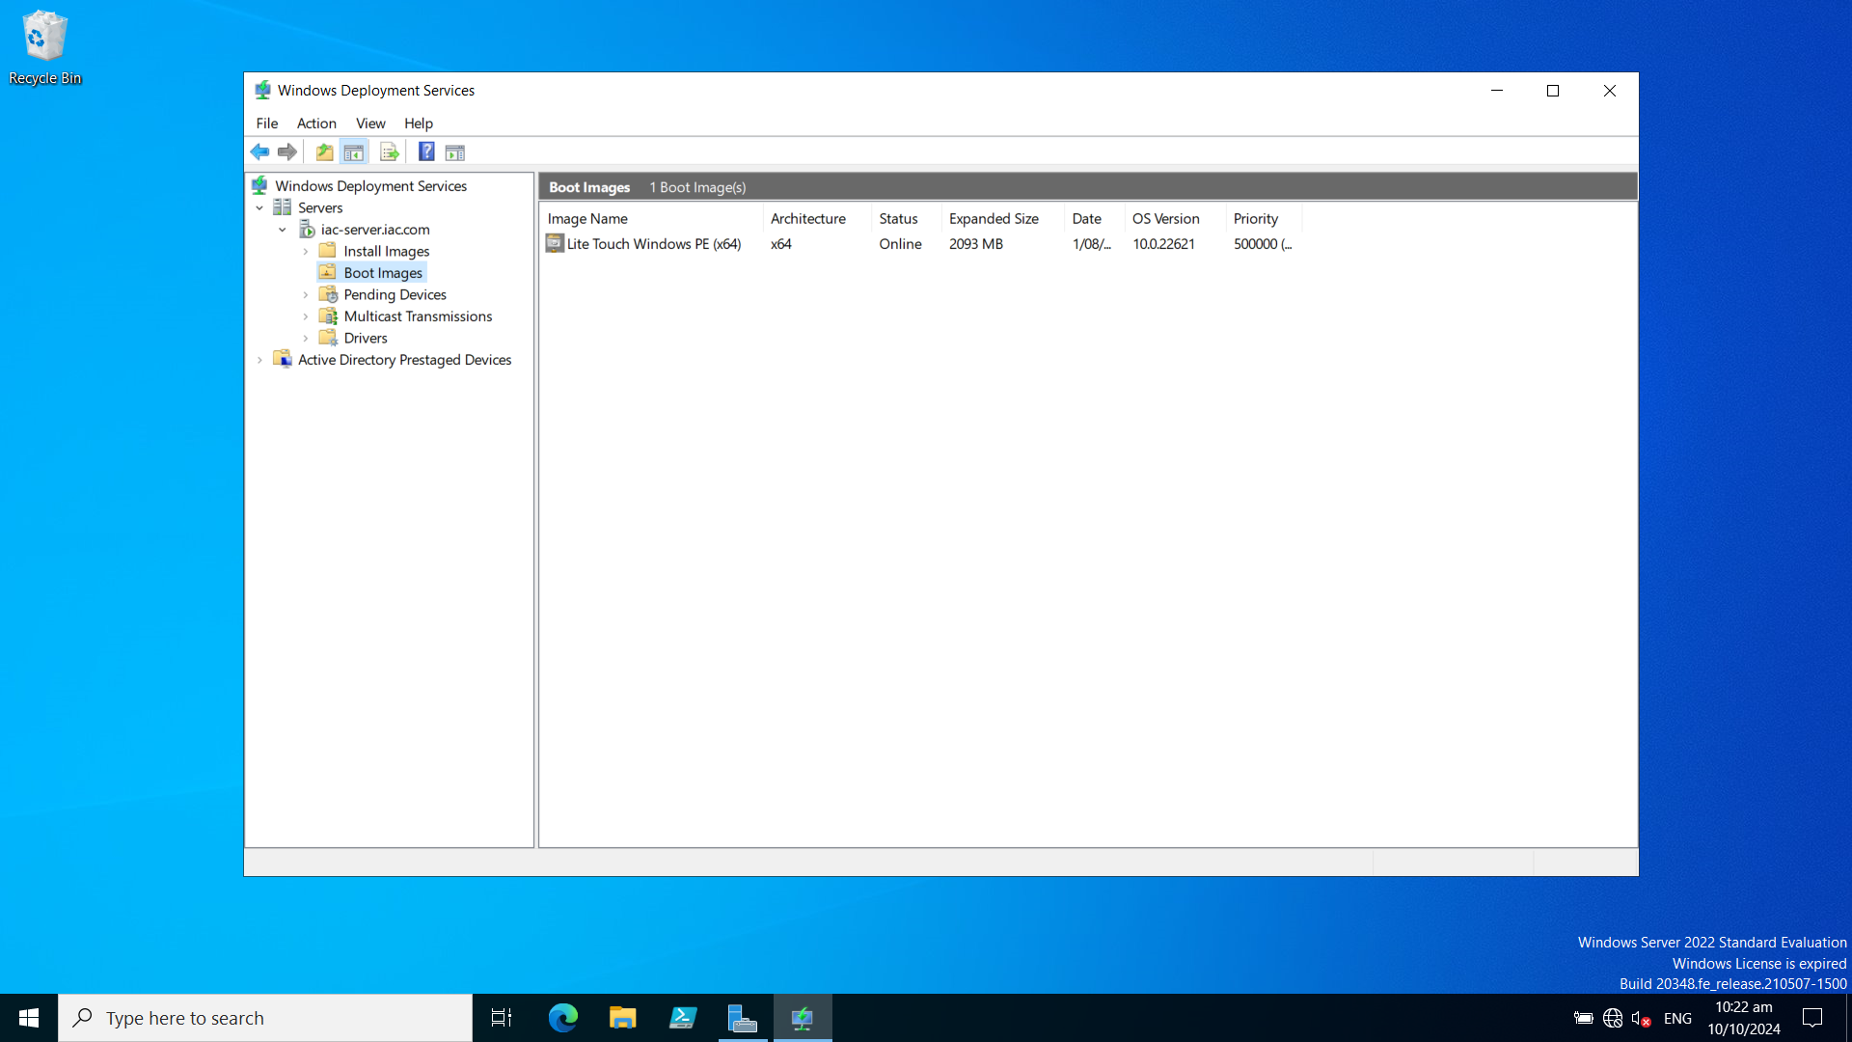

**2 . Set parameters for the client virtual machine**

